***Grocery Basket***

***Agenda***

* *Introduction*
* *Pre-requisites*
* *App Overview*
* *Concepts used*
* *Gradle dependencies used*
* *Material Components used*
* *Project’s Complete Code*
* *References*

***Introduction***

*Hi….  
This is Rammohan Locharla.*

*I build an application called* ***“Grocery Basket”*** *in android using android studio.*

*Many times, we forget to purchase things that we want to buy, after all, we can’t remember all the items, so with the help of this app, you can note down your grocery items that you are going to purchase, by doing this you can’t forget any items that you want to purchase.*

*Yours faithfully,*

*Rammohan Locharla*

*Mail:* [*locharla.rammohan@gmail.com*](mailto:locharla.rammohan@gmail.com)

*Mobile No: +91 8309583550*

*Google Developer Profile Link:* [*https://g.dev/rammohanlocharla*](https://g.dev/rammohanlocharla)

*SBID: SB20220248310*

*GitRepo ID: SPSGP-102704*

***Pre-requisites***

1. *Windows PC/Laptop or Apple Mac*
2. *Download and install Android Studio from the below link*

[*https://developer.android.com/studio*](https://developer.android.com/studio)

1. *Physical (I used OnePlus 8 Pro mobile) or Virtual Android mobile.*
2. *Internet Connection to access various resources.*
3. *USB Cable (in case of using physical device).*

***App Overview***

1. *This is my Grocery Basket App Icon*

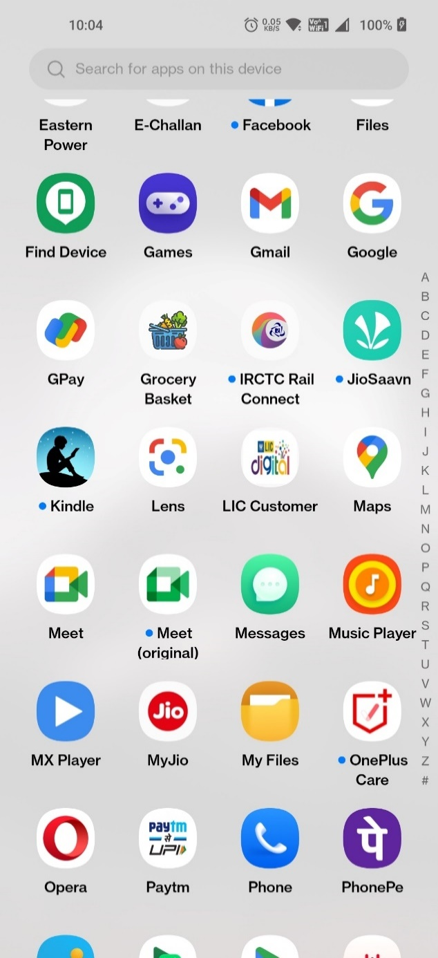

1. *On App Startup, This, will be the first screen on initial setup…*

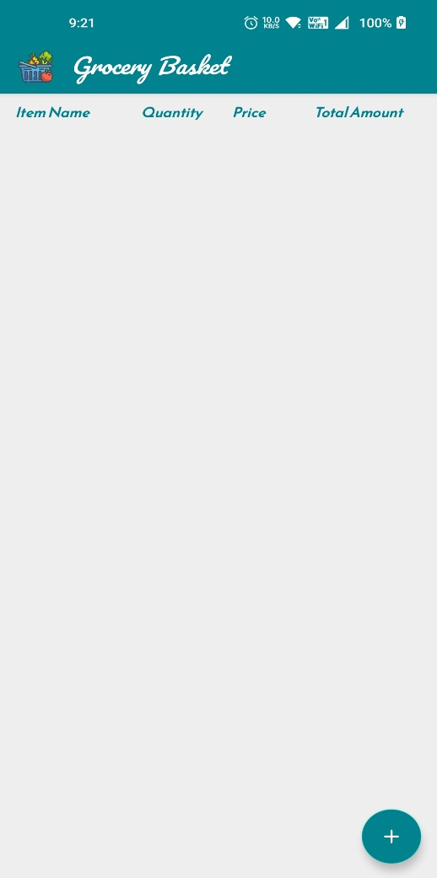

1. *Added custom app bar and toolbar on top side*
2. *Added App’s Icon and Title to the app bar*
3. *Headings relating to Items added in the apps*

*This will be Empty, since we haven’t added any items yet.*

1. *Click on Add FAB (i.e., Floating Action Button) on the bottom right to add items to the app and fill details in the text fields*

**

1. *On clicking Add FAB----Screen navigates to Add Item Fragment*
2. *We have to fill the details of item as shown in the picture*

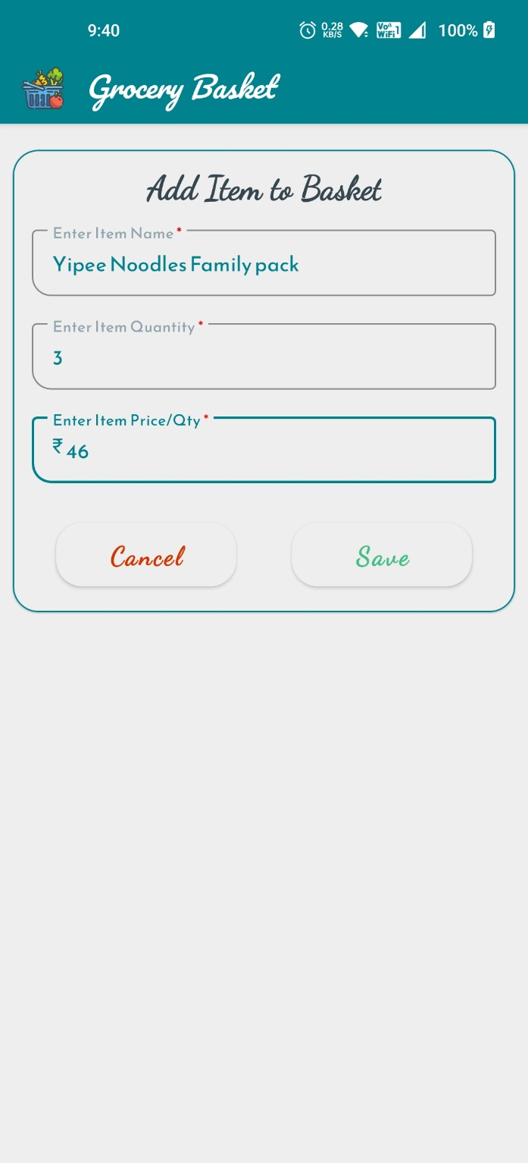

1. *After all fields are filled, clicking on Save Button, it saves the data in the app and show it in our Main screen*

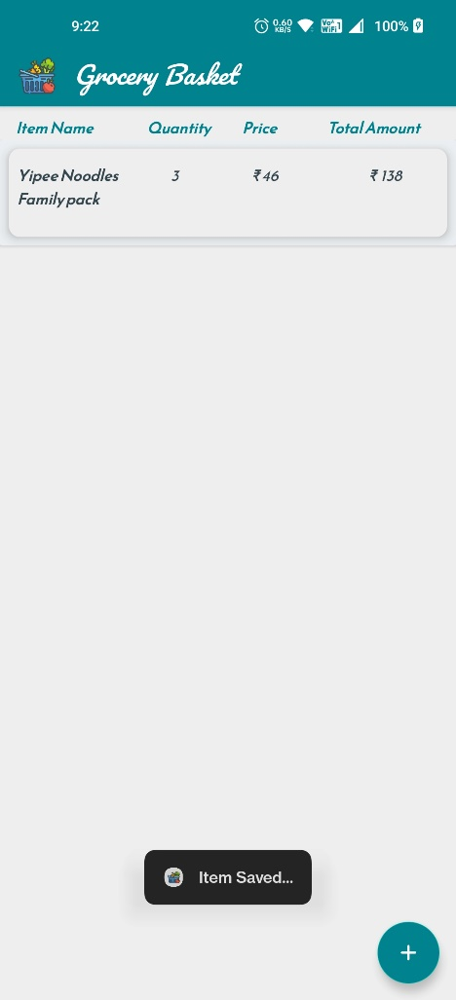

1. *There will be a* ***Toast message*** *will be shown at the bottom side when the item is saved in the app.*
2. *When click on cancel button in the Add Item screen, no item will be added to the app*

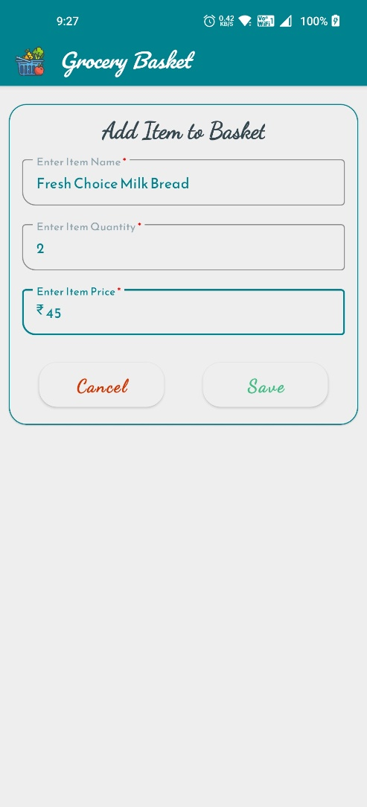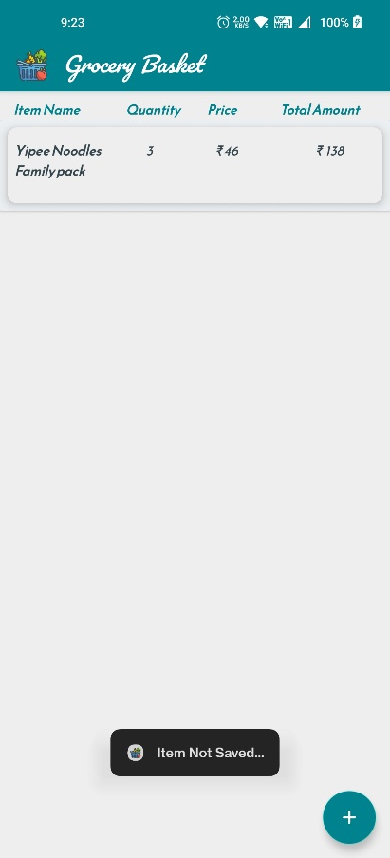

1. *There will be a* ***Toast message*** *will be shown at the bottom side when the item is* ***not saved*** *in the app.*
2. *On clicking on any item, it will navigate to Item Detail screen*

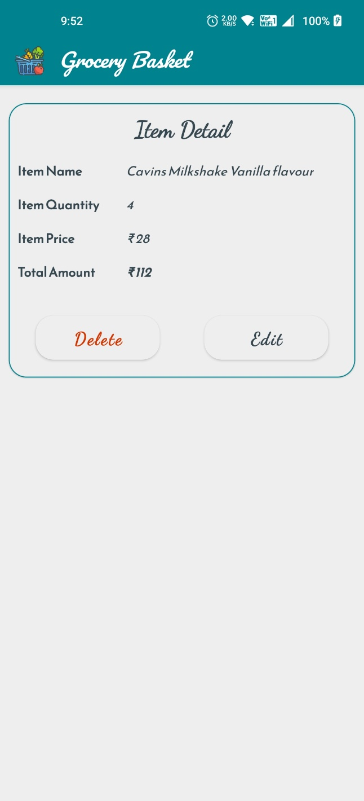

1. *This is the Item Detail screen, where we can see Grocery item details*
2. *There are two button at the bottom part.*
3. *If we click on the delete button, the item will be deleted from the app’s data. Here, we can see* ***Onions*** *item in the list, clicking on it shows us detail screen, clicking on Delete button, it will show us Confirm Delete dialog. If we click on* ***Yes*** *on the dialog, the item will be deleted.*

***Check the screenshots below***

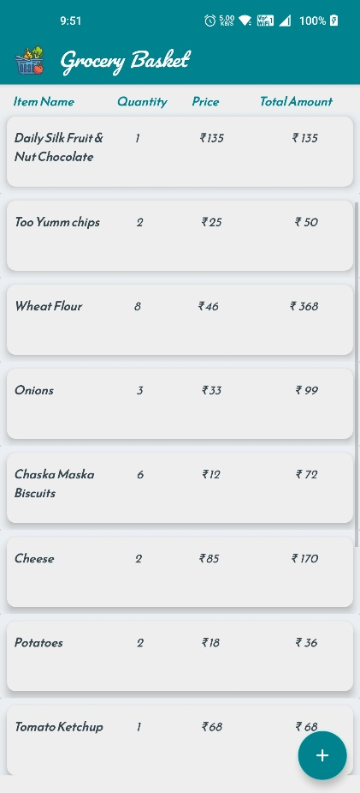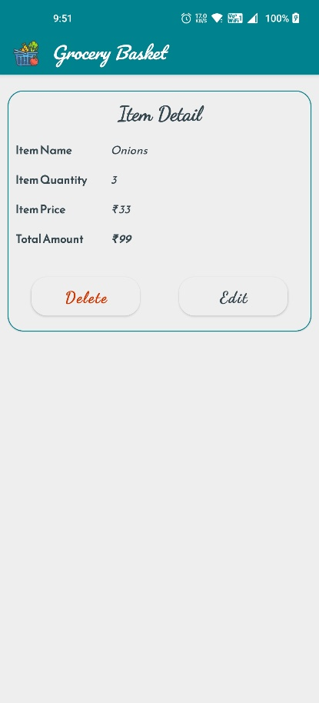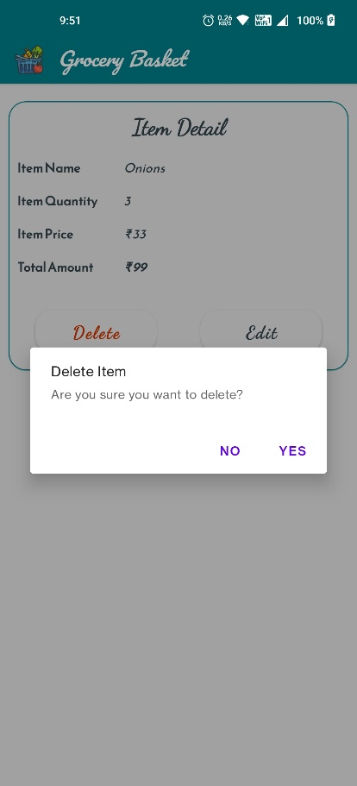

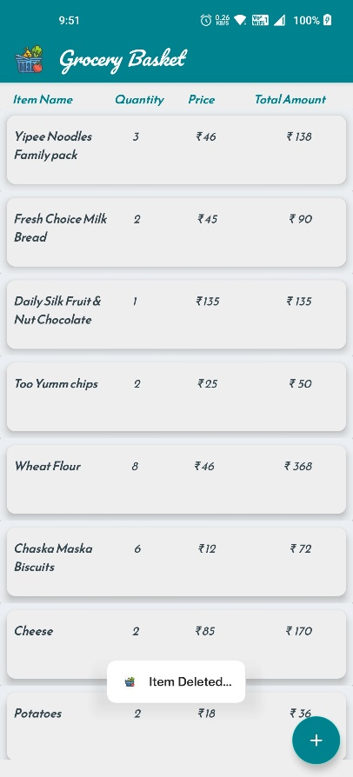

1. *There is a* ***Toast message*** *when the item is deleted from the list.*
2. *We can edit item in the list*
3. *First tap on any item*

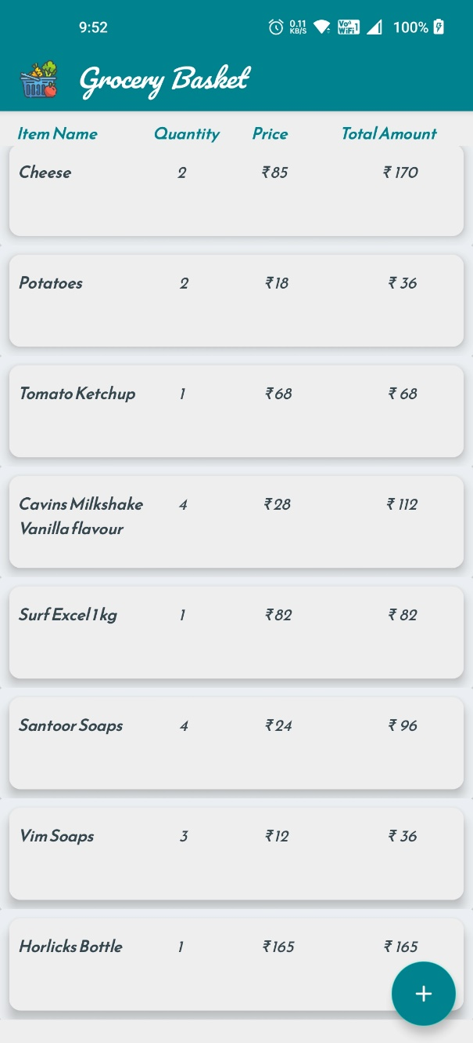

1. *It will go to detail screen, then click on edit icon, it will go to Edit item screen, there the fields are already fill the existing data. We can the change the data* ***(changing the flavor to Chocolate)*** *and click on save to get save in the app.*

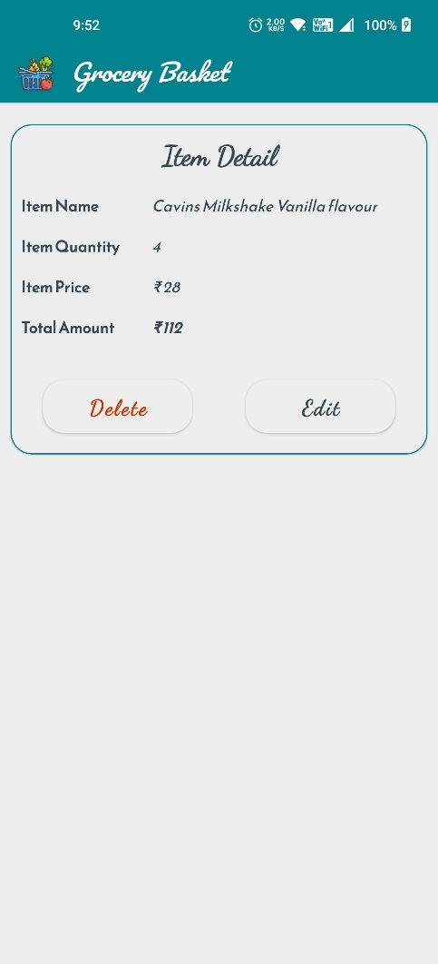 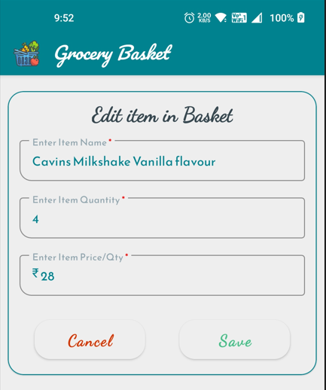

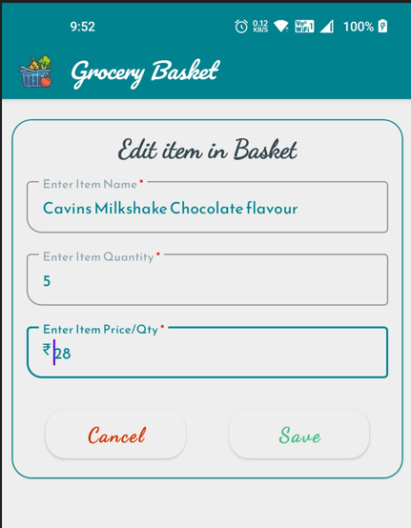 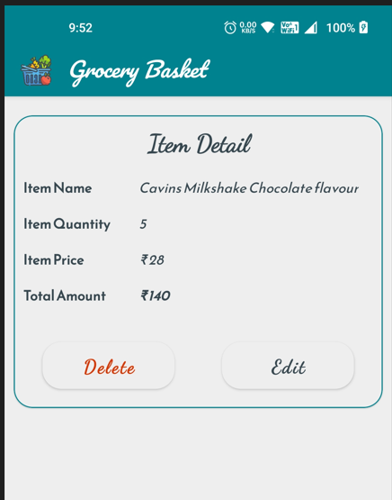

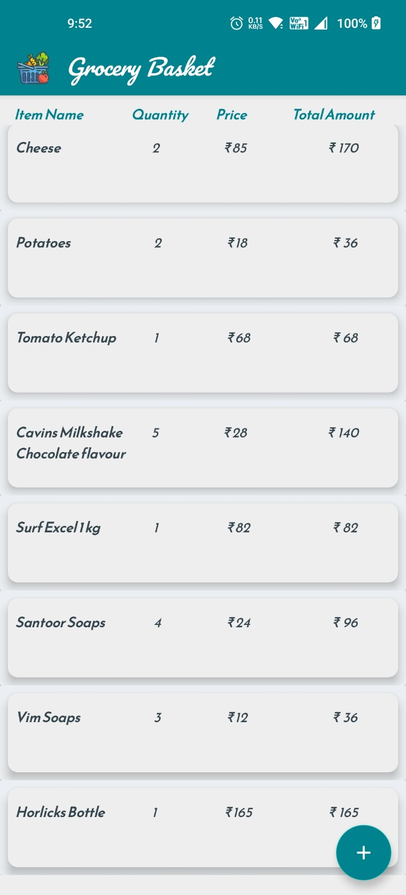

1. *Item details had changed after clicking on save button in the edit item screen*
2. *Flavor changed from* ***Vanilla*** *to* ***Chocolate***
3. *Item also got updated in the list in the same row*

***Concepts used***

* *Recycler View*
* *Card View*
* *Fragments*
* *Navigation*
* *ViewModel*
* *Coroutines*
* *Live Data*
* *Flow*
* *Room database*

*Also added simple transitions between Fragments.*

***Gradle dependencies used***

dependencies {  
  
 implementation 'androidx.core:core-ktx:1.7.0'  
 implementation 'androidx.appcompat:appcompat:1.5.1'  
 implementation 'com.google.android.material:material:1.6.1'  
 implementation 'androidx.constraintlayout:constraintlayout:2.1.4'  
 implementation 'androidx.cardview:cardview:1.0.0'  
 implementation 'androidx.recyclerview:recyclerview:1.2.1'  
  
 //Navigation Component  
 implementation "androidx.navigation:navigation-fragment-ktx:2.5.2"  
 implementation "androidx.navigation:navigation-ui-ktx:2.5.2"  
  
 //ViewModel and LiveData  
 implementation "androidx.lifecycle:lifecycle-viewmodel-ktx:2.5.1"  
 implementation "androidx.lifecycle:lifecycle-livedata-ktx:2.5.1"  
  
 //Room Database  
 implementation "androidx.room:room-runtime:2.4.3"  
 kapt "androidx.room:room-compiler:2.4.3"  
 implementation "androidx.room:room-ktx:2.4.3"  
  
 //test  
 testImplementation 'junit:junit:4.13.2'  
 androidTestImplementation 'androidx.test.ext:junit:1.1.3'  
 androidTestImplementation 'androidx.test.espresso:espresso-core:3.4.0'  
}

***Material Components used***

* *Text Fields*

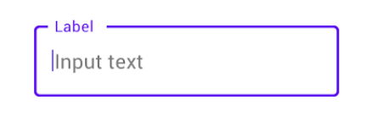

* *Dialog*

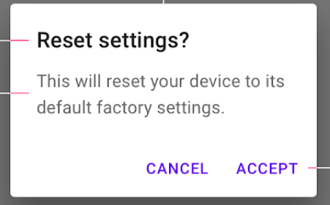

* *Buttons*

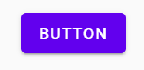

* *Card View*

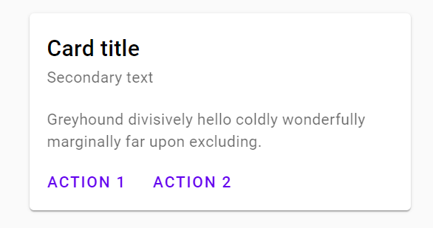

* *Floating Action Button*

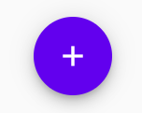

* *Top App bar*

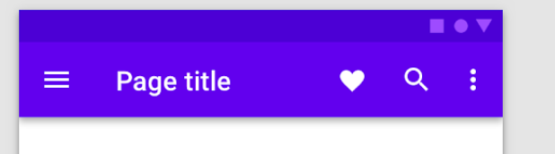

***Project’s Complete Code***

1. *Project tab in android studio screenshots*

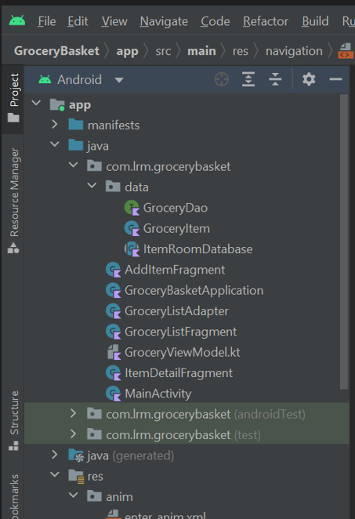 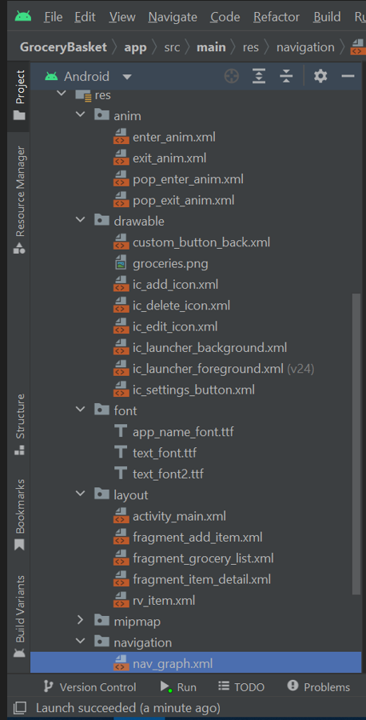

1. *For Complete code, please refer*
2. *Google Drive Link:* [Project Grocery Basket - Google Drive](https://drive.google.com/drive/u/0/folders/1kH8wVaqsDJh-8f0QUFLvtpqGpbXLgZt1)
3. *GitHub Link:* [smartinternz02/SPSGP-102704-Virtual-Internship---Android-Application-Development-Using-Kotlin: Virtual Internship - Android Application Development Using Kotlin (github.com)](https://github.com/smartinternz02/SPSGP-102704-Virtual-Internship---Android-Application-Development-Using-Kotlin)

***References***

* *For App Icons*
  + [*https://www.flaticon.com/search?word=Grocery%20Basket*](https://www.flaticon.com/search?word=Grocery%20Basket)
  + [*https://icons8.com/icons/set/grocery*](https://icons8.com/icons/set/grocery)
* *For colors used on layout, text, material components*
  + [*https://material.io/resources/color/#!/?view.left=0&view.right=0*](https://material.io/resources/color/#!/?view.left=0&view.right=0)
* *For Material components*
  + [*https://m3.material.io/components*](https://m3.material.io/components)
* *For Fonts styles*
  + [*https://fonts.google.com/*](https://fonts.google.com/)
* *For Knowledge on Android development concepts*

***Books***

* + *Head First Android Development using Kotlin*
  + *Android Apprentice*

***Complete guide to Project code***

* + [*https://www.youtube.com/watch?v=vdcLb_Y71Ic*](https://www.youtube.com/watch?v=vdcLb_Y71Ic)
  + [*https://developer.android.com/courses/android-basics-kotlin/unit-5*](https://developer.android.com/courses/android-basics-kotlin/unit-5)

**